Department: Computer Science and Engineering | Course Type: Programme Core
Course Title: Artificial Intelligence with Python Laboratory | Course Code: 18CSL58
L-T-P: 0-0-2 | Credits: 1
Total Contact Hours: 36Hours | Duration of SEE: 3 Hours
SEE Marks: 50 | CIE Marks: 50

COURSE DESCRIPTION
.

PREREQUISITES
- Basics of programming

COURSE OBJECTIVES
  - To
  - .
  - .
  - .
  - .

LABORATORY EXERCISES

- We have the Map of Romania. In this map, the distance between various places in Romania is given. If we have to reach from one place to another place there exist several paths. Write a Python Program to find the shortest distance between any two places using a A* search algorithm.

- Problem Statement for uniform cost search : For the Romania map, the distance between various places are given. If we have to reach from one place to another place there exist several paths. Write a Python Program to find the shortest distance between any two places using a uniform cost search.

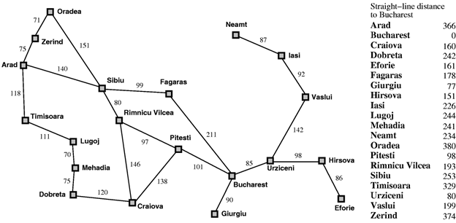
- Problem Statement for Depth Limited Search : Design and develop a program in Python to print all the nodes reachable from a given starting node in a graph by using the Depth Limited Search method. Repeat the experiment for different Graphs.

- Write a program to implement a Minimax decision-making algorithm, typically used in a turn-based, two player games. The goal of the algorithm is to find the optimal next move.

- Write a program to implement Alpha Beta pruning in Python. The algorithm can be applied to any depth of tree by not only pruning the tree leaves but also the entire subtree. Order the nodes in the tree such that the best nodes are checked first from the shallowest node.

- Assume that you are organizing a party for N people and have been given a list L of people who, for social reasons, should not sit at the same table. Furthermore, assume that you have C tables (that are infinitely large). Write a function layout(N,C,L) that can give a table placement (ie. a number from 0 . . . C − 1) for each guest such that there will be no social mishaps.
For simplicity we assume that you have a unique number 0 . . . N − 1 for each guest and that the list of restrictions is of the form [(X,Y), ...] denoting guests X, Y that are not allowed to sit together.
Answer with a dictionary mapping each guest into a table assignment, if there are no possible layouts of the guests you should answer False.

- Implementation of Tic Tac Toe game here ,the player needs to take turns marking the spaces in a 3x3 grid with their own marks, if 3 consecutive marks (Horizontal, Vertical,Diagonal) are formed then the player who owns these moves get won. Noughts and Crosses or X’s and O’s abbreviations can be used to play.

- Write a program to implement McCulloch-Pitts algorithms, for realizing the AND/OR/XOR/ANDNOT logic functions.

- Implement the Perceptron Learning single layer Algorithm by Initializing the weights and threshold. Execute the code and check, how many iterations are needed, until the network converge.

- Write a python program to implement neural networks with backpropagation for xor using one hidden layer.

- Suppose we have some pattern of arbitrary dimensions, however, we need them in one dimension or two dimensions. Then the process of feature mapping would be very useful to convert the wide pattern space into a typical feature space. Write a program to implement Kohonen algorithm
- Simulate the Mexican Hat Neural Network with fixed weight competitive net. External signals(S), number of iterations(t_max),Radius of region with positive reinforcement(R1), Radius of region with negative reinforcement(R2),vector of activations (X) are the inputs

Self-Study (No Implementation in the Exam) : Given Python code execution & analysis
Write a python program to implement The Wumpus world problem. The problem deals with an AI robot navigating its way through a 4x4 puzzle to try and find gold. The robot must safely navigate its way around bottomless pits of death and evil Wumpus creatures to locate the gold hidden on the board. After it has successfully found the gold, it must safely navigate its way back to the starting point. The robot must use its light sensors and the signals sent to it at each square to determine which way to properly navigate to reach its goal. –

Give the PEAS description and analyses the game wrt to knowledge base and how AGENT can succeed in grabbing the Gold and exit from the Wumpus World.
Simulate the 3 different scenario, of Wumpus World.

REFERENCES

If any

ASSESSMENTMETHODS

Parameter | Marks
Experiment write up, Execution, Viva & Record writing | 30
Lab Internal Test | 20
Total | 50
Final Exam will be conducted for 100 marks (SEE)

COURSE OUTCOMES
At the end of Course, Students will be able to

CO | Description | Blooms Level
CO 1:
CO 2:
CO 3:
CO 4
CO 5

Mapping of Course outcomes (COs) to Program outcomes (POs*)& PSO **
Course Outcomes mapping to Program Outcomes |  |  |  |  |  |  |  |  |  |  |  |  | PSOs
PO/CO | 1 | 2 | 3 | 4 | 5 | 6 | 7 | 8 | 9 | 10 | 11 | 12 | PSO1 | PSO2 | PSO3
CO1
CO2
CO3
CO4
CO5

